Nano WIRELESS N USB ADAPTER 150Mbps
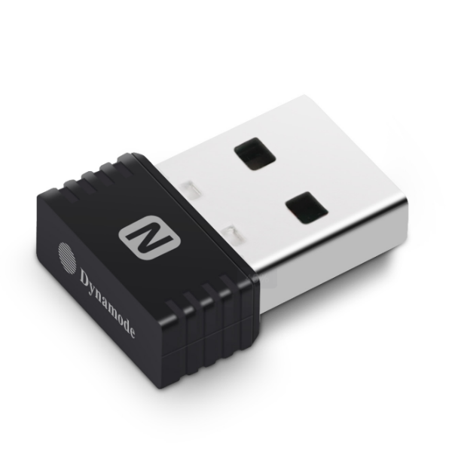
WL-700N-RXS

Description
The new WL-700N-RXS is your ideal partner for Notebook, Netbook and MacbookTM Computers. Featuring the new Dynamode Nano Wireless ASIC processor allows for one of the most compact Wireless 802.11n devices on the market. Fully compatible with WindowsTM, MAC OS XTM and LinuxTM, the WL-700N-RXS is compact enough so that it can be used as a direct replacement of your internal Wireless device and as such will not come loose when connected to a portable computer when enclosed in a Laptop bag for example.

Features
- 802.11n, 802.11g compliant WiFi
- Plug n' Play USB2.0 connection
- Supports multiple frequencies for a better connection
- Auto detects Wireless connection speeds
- Supports Soft Access Point Mode
- Supports WPA2, WPS and legacy Encryption modes
- Ultra Compact design - 'can be left as a permanent attachment for Notebooks’
- Ideal for Windows7TM, Windows10TM,MAC OS XTM and LinuxTM

Specifications
- Frequency Range: 2.412GHz~2.4835GHz
- Maximum Output Power: 18dbm
- Input Voltage Range (VAC): 5V
- Output Voltage Range(VDC): 1.5V/3.3V
- Speed 11b: 11 Mbps/5.5 Mbps/2 Mbps/1 Mbps
- Speed 11g: 54 Mbps /48 Mbps /36 Mbps /24 Mbps/18 Mbps/12 Mbps/9 Mbps/6 Mbps
- Speed 11n: 40M:135Mbps/121.5Mbps/108Mbps/81Mbps/54Mbps/40.5Mbps/27Mbps/13.5Mbps
- Max. Consumption: 0.6W
- Operating Temperature: 0℃ ~ 40℃
- Storage Temperature: -40℃~70℃
- Operating Humidity: 10%~ 90% RH Non-condensing
- Storage Humidity: 5% ~ 90% RH Non-condensing

